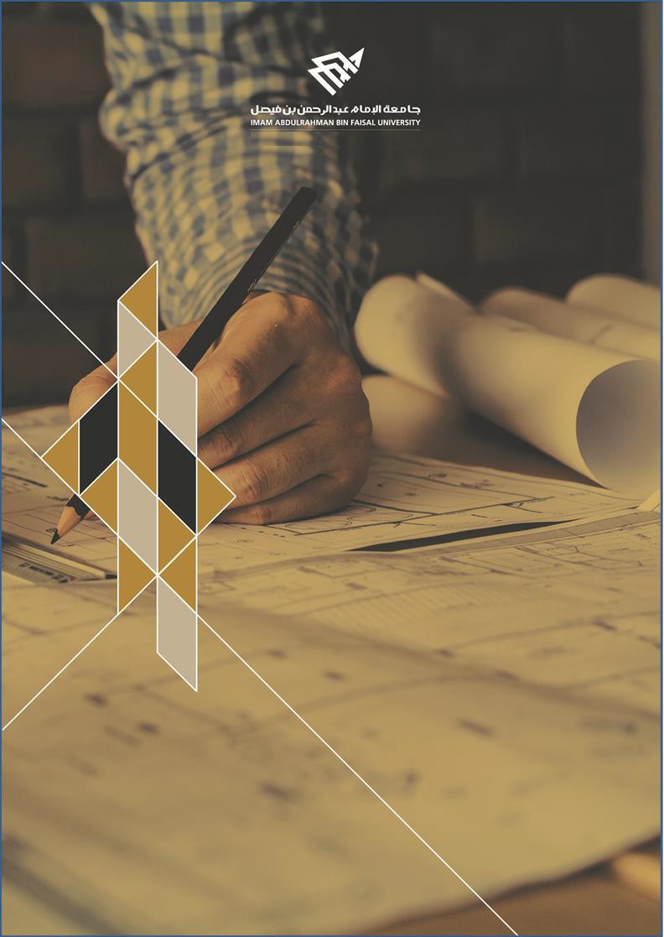

College of Computer Science and Information Technology
تامولعملا ةينقتو بساحلا مولع ةيلك

DEPARTMENT OF COMPUTER ENGINEERING

ARTI403 – Image Processing

STUDENT PROCEDURAL MANUAL Lab 1

2026 - 2027

Practical Session Plan

Session Topic/Title | Session No. | Session Duration  (Minutes)
Basics of programming with Python | 1 | 100

1- Session
Outcomes

Outcome#1: Explain how digital images are represented and manipulated in a computer.

2- Tool(s)/Software .
• Python 3
• Anaconda
• IDE for Python: Jupyter, Spyder.

3- procedural steps
(Tasks)

Step#1:Install Anaconda:

Download and install the latest version of Anaconda from https://www.anaconda.com/
After installation and running Anaconda, you will get a similar environment where Jupyter and Spyder are already installed, which are the target tools for this course.

Step#2: Start Jupyter or Spyder for Python.

You can start Jupyter or Spyder from the Anaconda GUI (which is the most time-consuming task. You can also start Jupyter or Spyder directly from the Start menu (without starting Anaconda).

Step#3: Install Libraries / Packages in Python:

Most of the time, you will need libraries/Packages in Python during your work. You will need the following libraries: SkyPi, OpenCV, scikit-image, Pillow, Matplotlib.

Step#4: Install NumPy:
Practical Session Plan

Google for NumPy, you will find some link, one of them will be NumPy.py (https://pypi.org/project/numpy/) copy and paste it in the command prompt of Jupyter and Spyder and it will be installed locally

Task#1: Exercise with Spyder:

Exercise the two cheat sheets for Python practice in the resources section.

Task #2: Loading and Visualizing Images:

- Loading/reading an image using OpenCV

import cv2
img = cv2.imread('images/cameraman.tif') #Load the image data into a NumPy array

import matplotlib.pyplot as plt
plt.imshow(img)
plt.show()

- Loading/reading image using PIL

from PIL import Image
img2 = Image.open('images/lena_gray_256.tif') #load image into a PIL Image object

import matplotlib.pyplot as plt
import matplotlib.cm as cm
plt.imshow(img2, cmap = cm.Greys_r)
plt.show()

Task #3: Image Storing
- Saving image to disk using OpenCV

cv2.imwrite('new_image.jpg', img)

- Saving an image to disk using PIL

img2.save('new_image2.jpg')

Task #4: Display image as an Array

print(img.shape) #Note: img1 loaded using open cv is a numpy array
print(img)

import numpy as np
# Convert the image to a NumPy array
img_array = np.array(img2)

# Print the array
print(img_array.shape)
print(img_array)

4- Assessment

The student will be asked to perform different operations on the array using the NumPy library.

5- Resources

NumPy cheat sheet

Python Basics cheat sheet

